Heidelberg Alla hopp! complex with sports surfaces from Polytan:
Space for exercise, sport and fun
A total of 19 "Alla hopp! complexes" are to be built in the Rhine-Neckar metropolitan region with donations from the Dietmar Hopp Foundation. The opening ceremony for the fifteenth exercise and meeting place was held in Heidelberg, the birthplace of Dietmar Hopp, in October 2016. Four more complexes will follow in 2017. The Heidelberg complex is a landscaped park and boasts many sports and play areas fitted out with high-quality synthetic surfaces from Polytan. As soft-impact surfaces and synthetic turf they protect children from injury, while as high-quality tracks they provide an optimally cushioned base that is easy on the joints of amateur athletes.
The aim of the Dietmar Hopp Foundation is for the "Alla hopp! complexes" to provide freely accessible sports facilities in which people of all ages can take exercise, keep fit and relax as and when they choose. They are supervised by trained sports educators who are on hand to ensure that the equipment is used correctly and thus promote a healthy lifestyle. Every Alla hopp! complex lies within a landscaped park and is composed of three or four modules – themed areas – which overlap and are aimed at various age groups. The new exercise and meeting place in Heidelberg extends over an area of 13,600 square metres and was designed by Schelhorn Landschaftsarchitektur, a firm of landscape architects.
Division into four age-appropriate modules
Module 1 is an exercise course for all ages and levels. It is similar to circuit training in the sense that athletes can use different equipment to improve their mobility, coordination, stamina and strength. A 120-millimetre thick PolyPlay FS soft-impact surface from Polytan around the arch ladder protects the users from injury if they are unlucky enough to fall, for example. Polytan designed a plastic cover that can be lifted as and when required in order to provide access to the column foundations of the arch ladder for the annual inspection in compliance with DIN EN 1176.
Module 2 is the children's playground and is especially suitable for youngsters up to the age of six. Children's motor skills, sensory perception and cognition are developed here during the rough and tumble of play. There is a play pavilion with rotating elements, including a spinning bowl for example, for use when the weather is bad. Polytan installed a 14 x 14 m synthetic turf pitch as a base. The chosen system, LigaGrass Pro CoolPlus, is robust and easy to maintain thanks to its textured filaments and it feels pleasantly soft to the skin. Sand was selected as the filling, whilst the 30-centimetre thick elastic layer provides optimal cushioning for children to charge around.
Older children between the ages of six and twelve can climb, swing and balance in the "mountains", on the slackline or in the swing park of module 3 and thus improve their motor skills and mobility.
Module 4 is attuned to the requirements of the over-12s and is a demanding exercise area with a streetball court, weight training and climbing. The easy-to-maintain, DIN EN 1177 HIC-tested PolyPlay FS soft-impact surface from Polytan laid in the climbing playground has a cushioning action to protect climbers against injury. The surface is also water-permeable to prevent it from becoming waterlogged and a slip hazard when it rains.
The centrepiece of the complex: the track
A particular attraction of the Alla hopp! complex in Heidelberg is the 125 m long, 3.60 m wide running track with some undulating sections. It runs through the whole site, with the words "Start" and "Finish" replaced with "alla" and "hopp" written in big letters on the four lanes. The durable all-round PolyPlay S system by Polytan was chosen in order to provide the best possible surface for athletes. The synthetic surface is 40 millimetres thick and water permeable with a smooth but non-slip top layer. Its other attributes are high wear resistance and low maintenance costs. The seamless in-situ installation method allows the two-course surface to be installed without any problem on undulating and angled substrates as well. The undulating substructure in Heidelberg consists of pervious concrete and steel plates for lateral stabilisation.
Further sections of the complex were also fitted out with the PolyPlay FS soft-impact surface from Polytan – including the horizontal bar in the centre of the track, the "family carousel" and the "Mikado wood". The extensive facilities are rounded off by a ropeway, drinking water fountains, bicycle parking, an e-bike charging station, toilets with nappy-changing tables, a dog station and a flight of steps painted by children. The yellow Alla hopp! umbrella at the entrance is both an emblem and a highly visible meeting point for the whole complex.
Captions:
Picture credits, all: Tomislav Vukosav / Polytan
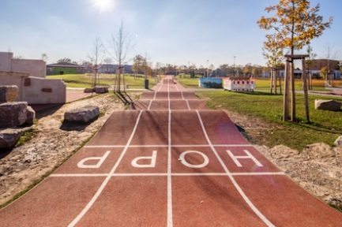 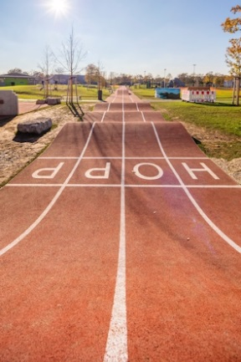
Polytan_Alla_Hopp_01.jpg Polytan_ Alla_Hopp_02.jpg
The track in the Heidelberg "Alla hopp! complex" is over 100 metres long and was made from the durable multi-purpose PolyPlay S synthetic surface from Polytan.
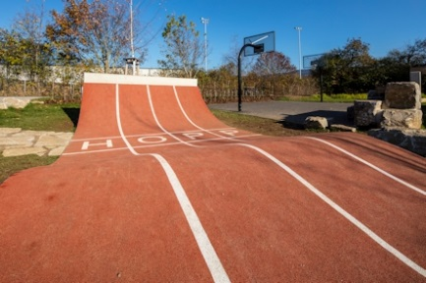
Polytan_Alla_Hopp_03.jpg
The seamless Polytan synthetic surface is installed in situ and can therefore be used on undulating and curved substrates without any problem.
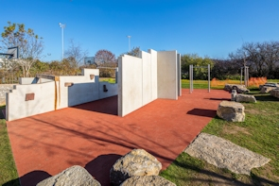
Polytan_Alla_Hopp_04.jpg
An area of around 110 square metres in the climbing playground was fitted out with a PolyPlay FS soft-impact surface from Polytan.
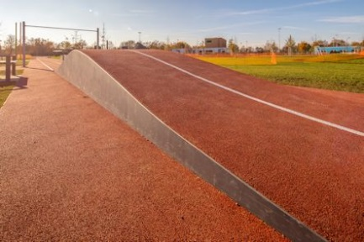 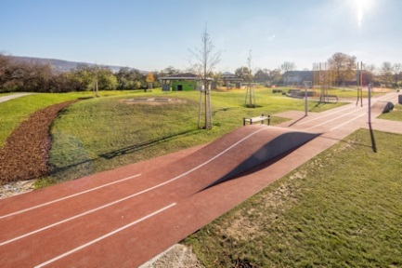
Polytan_Alla_Hopp_05.jpg Polytan_Alla_Hopp_06.jpg
The undulations are worked into the track to develop the coordination and skills of the runners. The smooth surface is water permeable, non-slip and easy to maintain.
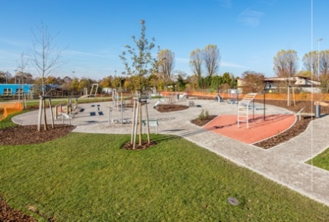 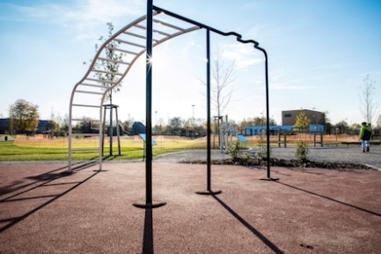
Polytan_Alla_Hopp_07.jpg Polytan_Alla_Hopp_08.jpg
The exercise course has a "Muckibude" (muscle factory) and is laid out like a training circuit. A 40 square metre soft-impact PolyPlay FS synthetic surface beneath the arch ladder guards against injury.
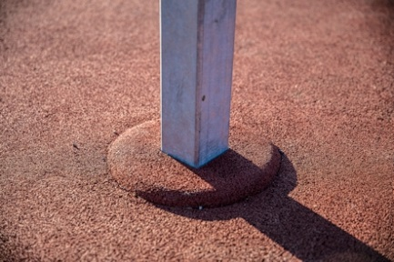
Polytan_Alla_Hopp_08a.jpg
It was a particular technical challenge to integrate the post construction of the arch ladder into the soft-impact surface: A small plastic cover can simply be raised when it's time for the annual inspection of the playground in compliance with DIN EN 1176.
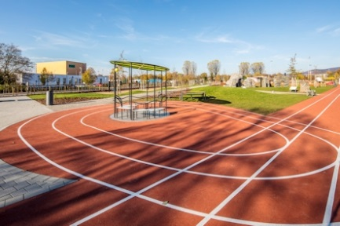
Polytan_Alla_Hopp_09.jpg
The ground around the family carousel, which intersects the track, was also attractively designed with a Polytan synthetic surface.
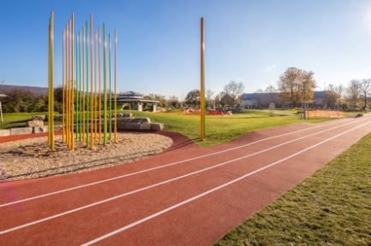
Polytan_Alla_Hopp_10.jpg
The Mikado wood directly on the track forms the centre of the Heidelberg Alla hopp! complex.
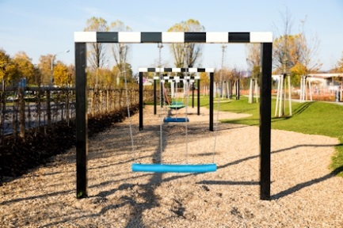
Polytan_Alla_Hopp_11.jpg
The swing park is part of module 3 on the complex and is aimed at children between the ages of six and twelve.

CONSTRUCTION SITE SIGN:
Client: Dietmar Hopp Stiftung GmbH, St. Leon-Rot, www.alla-hopp.de
Landscape architect: Schelhorn Landschaftsarchitektur, http://www.schelhorn-landschaftsarchitektur.de
Ground-breaking ceremony: 11.03.2016
Opening: 13 October 2016
Surface area: 13,600 m²
Location: Harbigweg 11, Heidelberg
Polytan products:
- Track: PolyPlay S, 125 x 3.60 m, d = 40 mm
- Soft-impact, horizontal bar: PolyPlay FS, d = 120 mm
- Soft-impact, climbing trail: PolyPlay FS, approx. 110 m², d = 120 mm
- Soft-impact, arch ladder: PolyPlay FS approx. 40 m², d = 120 mm
- Synthetic turf system, play pavilion: LigaGrass Pro CP, 14 x 14 m, sand filling

Polytan GmbH:
To make the optimal surface for sporting success – that has been the ideal pursued by Polytan since 1969. With a constant eye on the latest findings in the field of sports medicine, the specialist in outdoor sports surfaces is continuously refining its synthetic surfaces and synthetic turf systems. Today's synthetic turf pitches not only feel like real grass, for example, but they also have excellent playing qualities. High-quality synthetic surfaces now range from shock-absorbing soft-impact surfaces and multi-functional all-weather pitches all the way to high-speed surfaces for international athletics events. As well as developing, manufacturing and fitting its own sports surfaces, the spectrum of services provided by Polytan also includes line markings, repairs, cleaning and maintenance. All products meet current national and international standards and are duly certified by international sports federations such as FIFA, FIH, World Rugby and IAAF.

Agency contact:
Seifert PR GmbH (GPRA)
Barbara Mäurle
Zettachring 2a
70567 Stuttgart
0711 / 77918-26
barbara.maeurle@seifert-pr.de

Company contact:
Polytan GmbH
Tobias Müller
Gewerbering 3
86666 Burgheim
08432 / 8771
tobias.mueller@polytan.com

