Heated, soft and springy:
Extraordinary running tracks for Norwegian athletes
Training conditions for amateur and professional athletes in the municipality of Evje og Hornnes in the south of Norway have been extraordinarily good since the installation of a new athletic facility: as the first sports facility in this Scandinavian country, the Hornnes Idrettspark has both a heated track and a soft, springy one designed to be easy on the joints, which makes it ideal for daily or intensive training sessions.
The outdoor sports park consists of a 100 x 64 metre football pitch with the athletics facilities arranged around it. It has five discus throwing circles, two shot put rings, a long jump and triple jump, each of which has its own run-up, three long jump pits and six circular tracks for competitions. The seventh, outside lane is a particularly soft track and is coloured green to make it stand out from the other, brick red lanes.
Polytan WSS, an all-round surface for professional requirements, has been installed on all the red running and run-up tracks. The 15 mm thick synthetic coating is water-permeable so that rainwater can also drain away vertically, thus reducing the amount of surface water on the track. The structured surface is also designed to be non-slip and ideally suited to spikes. As the main sprint track, lane number four has undersoil heating to keep it free of ice and snow all year.
The structure of the seventh, green "jogging lane" was installed in line with the specific requirements of the customer, who wanted a springy base for high volume running, all types of intervals (sprint and distance intervals) and plyometric work, which is special jump training designed to increase power and improve performance. With a surface that is easy on the joints, the track is also suitable for amateur athletes carrying extra weight.
The bottom elastic layer is between 25 and 30 millimetres thick and was made from newly manufactured running track granules – elastic layers such as this normally consist of black, certified recycling material and are used in synthetic turf systems. The second, middle layer, a 10-11 millimetre synthetic coating made from Polytan SE in "reseda green", comes next and is topped off by the final layer, a 2-3 millimetre spray coating of the water-permeable all-rounder Polytan WS, likewise in reseda green.
The training and competition conditions in the Hornnes Idrettspark are unique in Norway and can be attributed to the commitment of national coach Olav Tveitå. He is particularly thrilled by the success of the green track: "Professional and amateur athletes from the local area are delighted and put in 90 per cent of their training on it. This is because the surface is yielding – but not excessively so. I think we've found the best possible shock absorbency."
Further information on synthetic surfaces from Polytan can be found at www.polytan.com.

Captions: (Photographs: Tomislav Vukosav / Polytan)
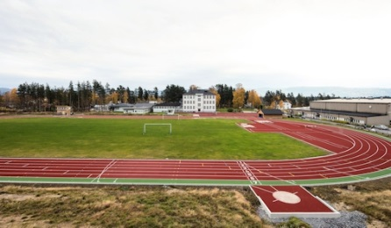 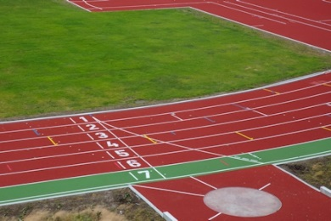
Hornnes_Idrettspark_01.jpg Hornnes_Idrettspark_02.jpg
The sports park in Evje og Hornnes in Norway was built on the initiative of national coach Olav Tveitå, who has already prepared sporting greats such as three-time Olympians Ezinne Okparaebo and Jason Ndure for international competitions.
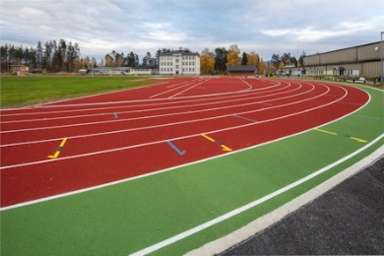 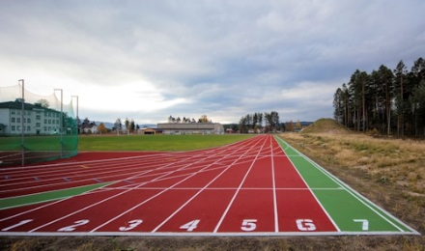
Hornnes_Idrettspark_03.jpg Hornnes_Idrettspark_04.jpg
Lane four is heated, while the exceptionally high shock absorbency of lane seven makes it ideal for frequent running, sprinting and speed-strength training.

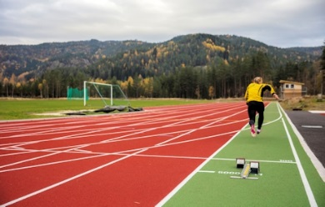 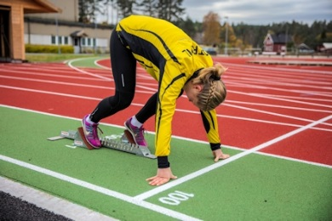
Hornnes_Idrettspark_05.jpg Hornnes_Idrettspark_06.jpg
The soft track is very popular with the athletes and is finished in a "reseda green" colour to stand out from the other competition tracks.

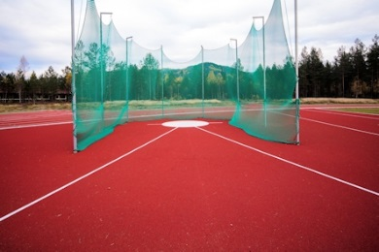 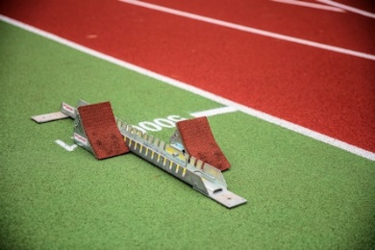
Hornnes_Idrettspark_07.jpg Hornnes_Idrettspark_08.jpg
The installed synthetic Polytan WSS (red) and Polytan WS (green) surfaces are water-permeable – so standing water can also drain away directly.

To make the optimal surface for sporting success – that has been the ideal pursued by Polytan since 1969. With a constant eye on the latest findings in the field of sports medicine, the specialist in outdoor sports surfaces is continuously refining its synthetic surfaces and synthetic turf systems. Today's synthetic turf pitches not only feel like real grass, for example, but they also have excellent playing qualities. High-quality synthetic surfaces now range from shock-absorbing soft-impact surfaces and multi-functional all-weather pitches all the way to high-speed surfaces for international athletics events. As well as developing, manufacturing and fitting its own sports surfaces, the spectrum of services provided by Polytan also includes line markings, repairs, cleaning and maintenance. All products meet current national and international standards and are duly certified by international sports federations such as FIFA, FIH, World Rugby and IAAF.

Agency contact:
Seifert PR GmbH (GPRA)
Barbara Mäurle
Zettachring 2a
70567 Stuttgart
0711 / 77918-26
barbara.maeurle@seifert-pr.de

Company contact:
Polytan GmbH
Tobias Müller
Gewerbering 3
86666 Burgheim
08432 / 8771
tobias.mueller@polytan.com

